**Assignment -7**

Question 1:

Create your own new custom VPC

- And configure your EC2 Linux instance inside your custom VPC

- and then create 3 subnets of that VPC

- Attach an internet gateway to your custom VPC

**Ans:**

* Created own new custom VPCnamed:**– test- vpc**
* Configured EC2 Linux instance named **test-EC2** inside custom VPC **test-vpc**
* And created 3 subnets: **subnet-1 subnet-2 subnet-3** in 3 different AZ’s with different IPV4 CIDR range subnets

* Created internet gateway **test-igw** and attached to custom vpc **test-vpc**

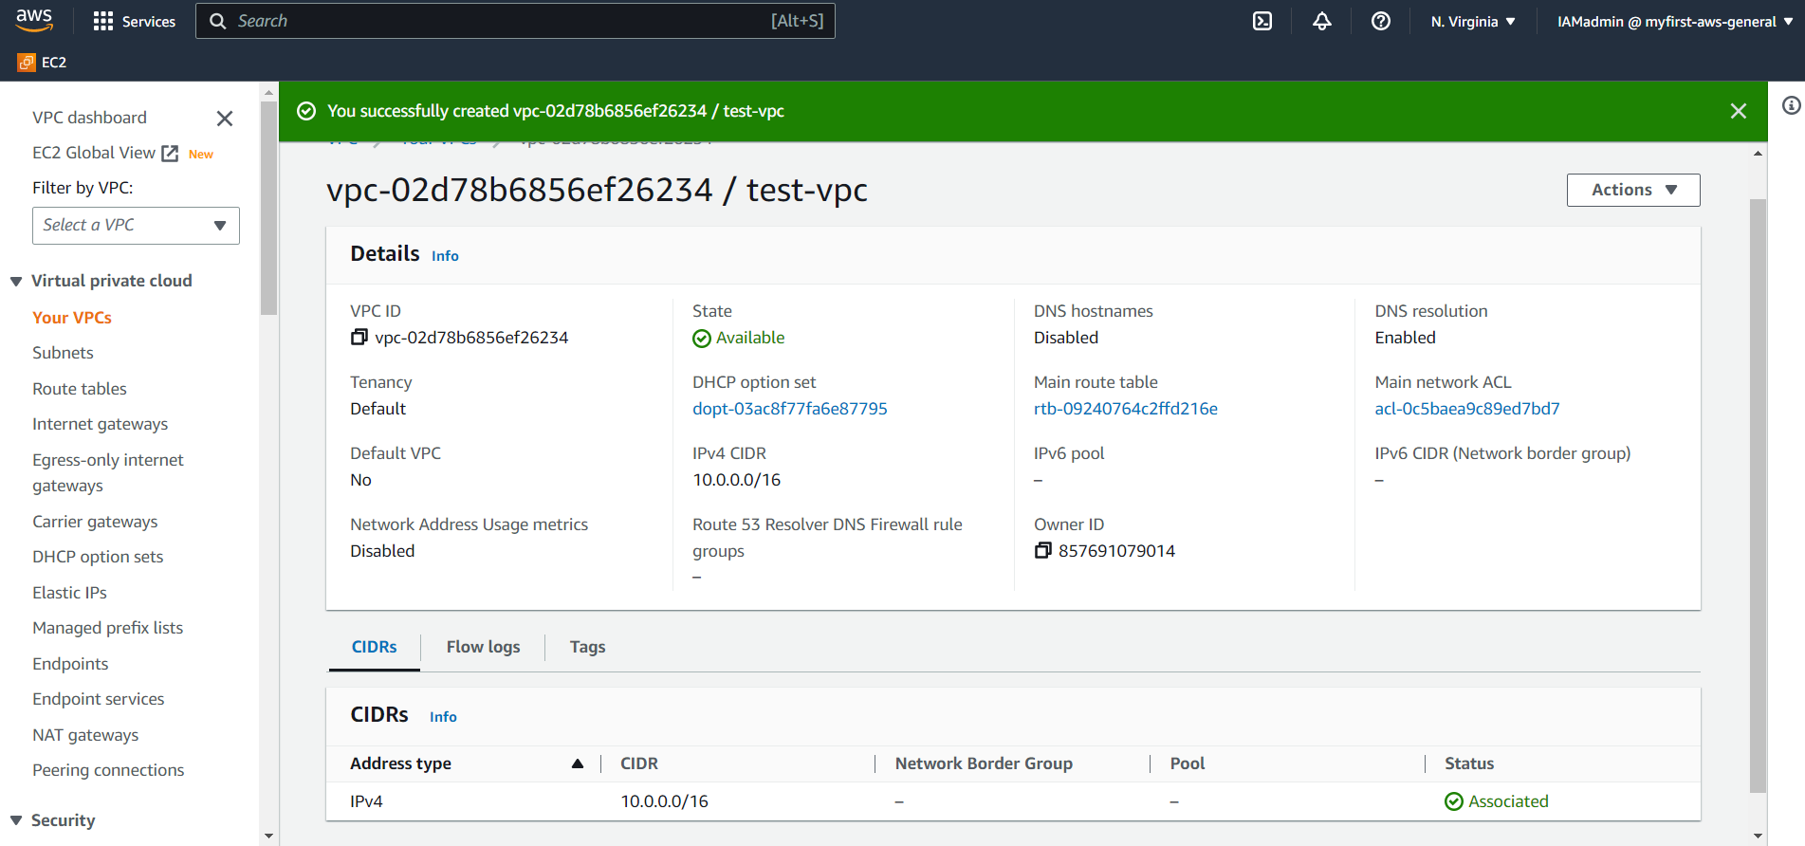

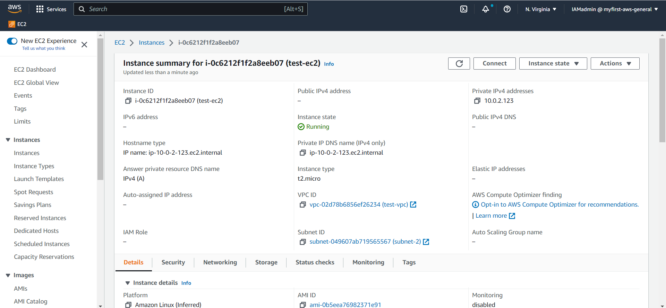

**3 subets created**

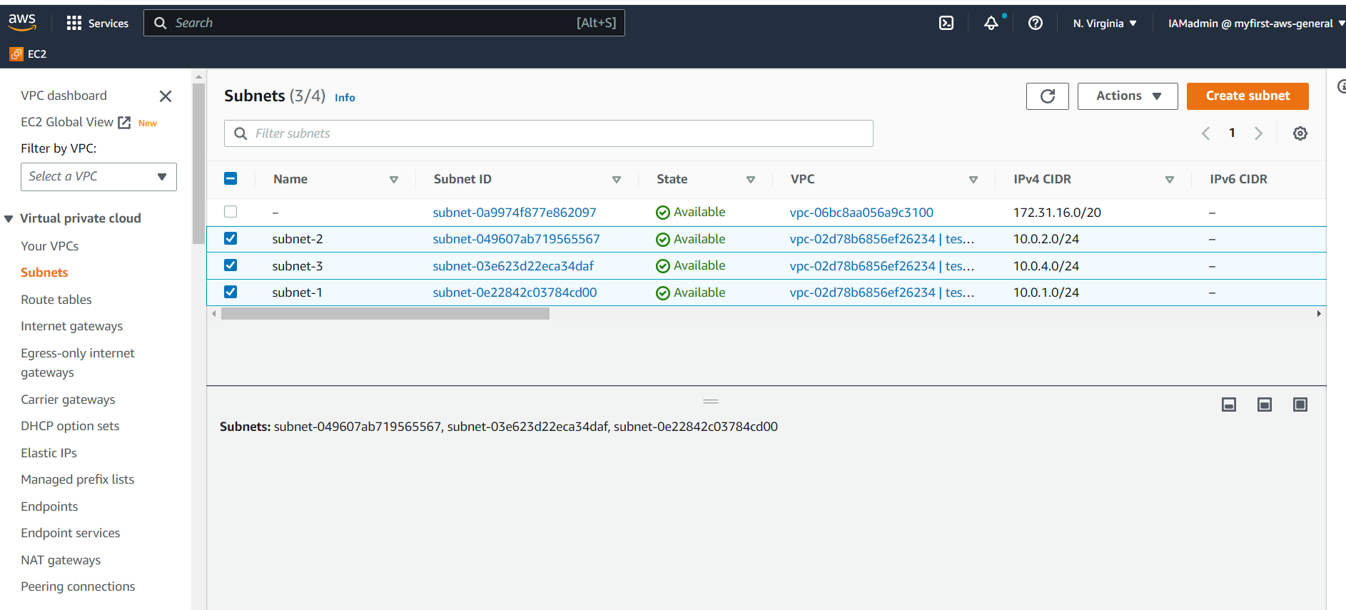

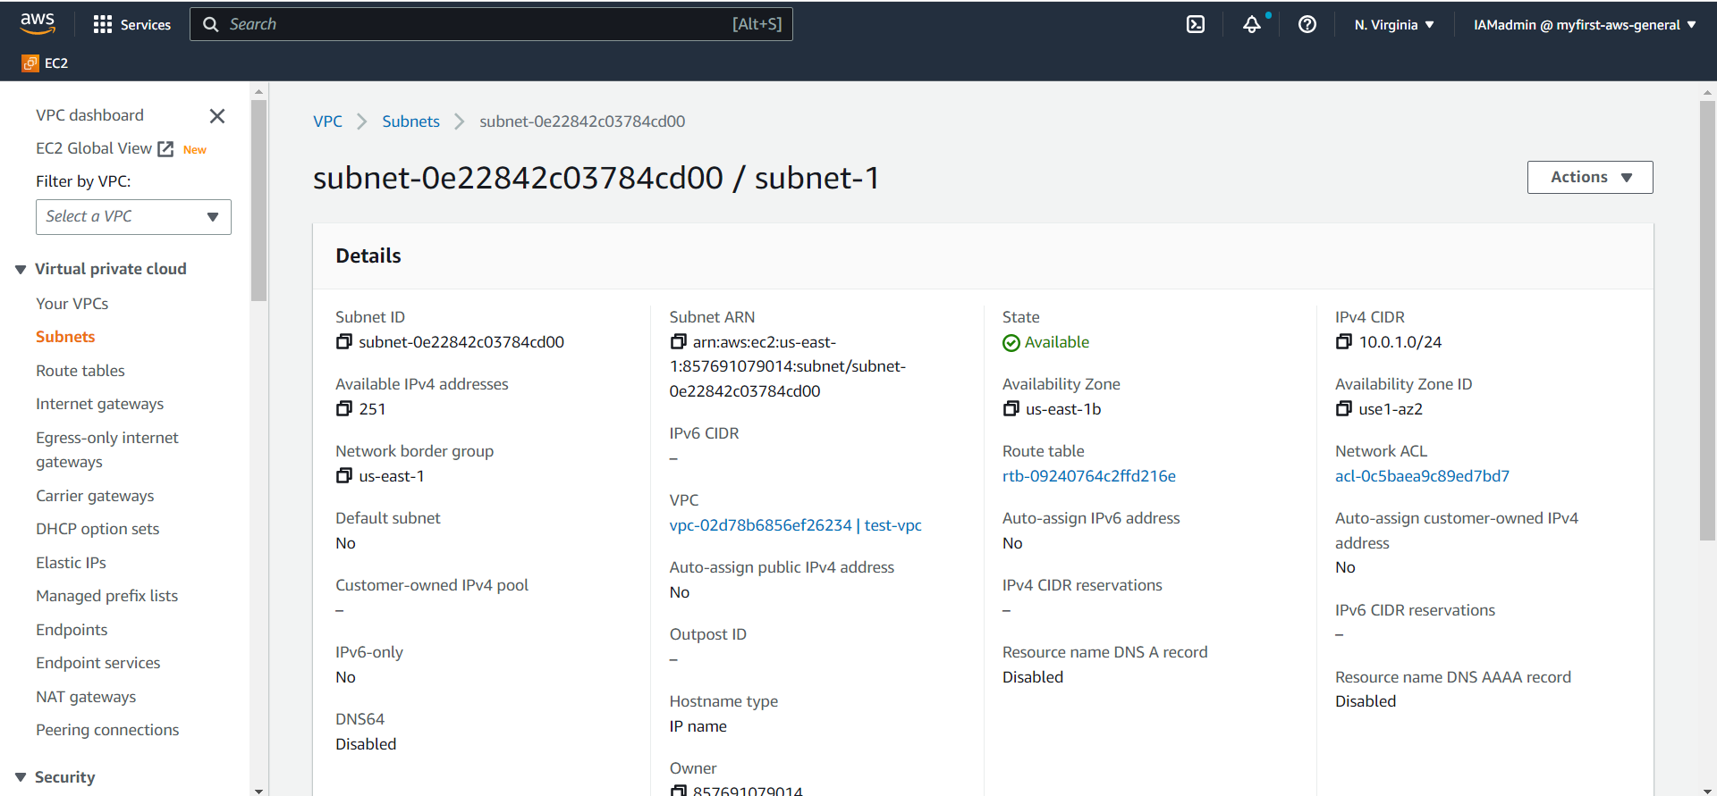

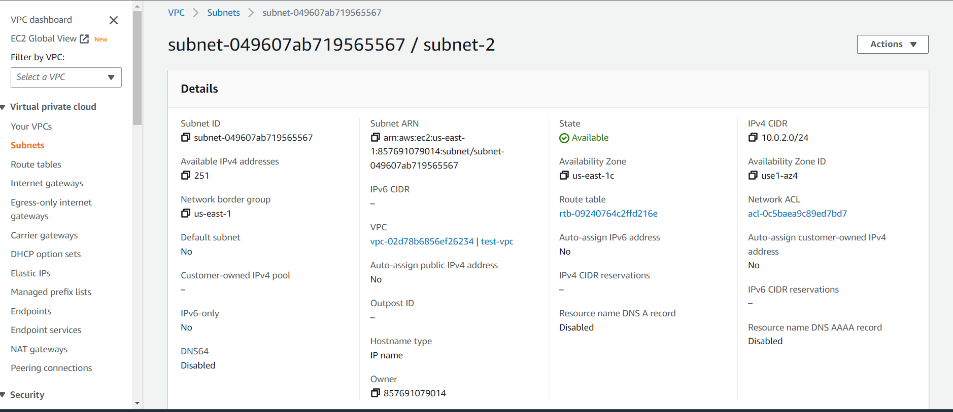

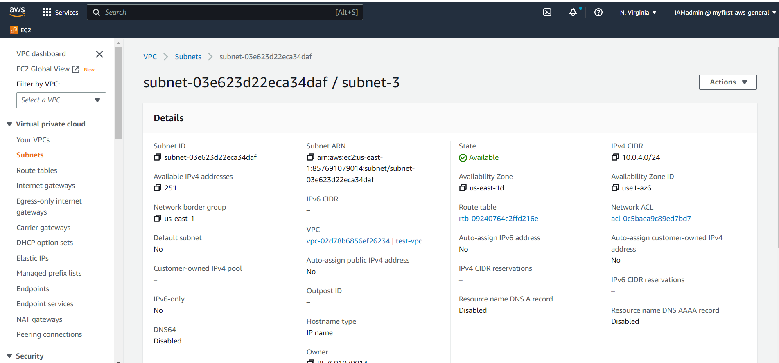

**Created internet gateway – test-igw**

